Juliette Joseph-Odogbo
Security Part 2
12/2/2025

Ubuntu Troubleshooting Report — Break Script Assignment
Introduction
For this assignment, I ran the break_system.sh script on my Ubuntu Server VM.
The purpose of the script is to intentionally break parts of the system so I can practice Linux troubleshooting.
After running the script, I checked the system using basic network commands.
Below are the problems I found and the exact solutions I applied.

Script Transfer & Permission Setup
Before running the professor’s break script, I first transferred the script file into each server. The file arrived as a plain text document, so the system did not recognize it as an executable program. To fix this, I converted it into a runnable shell script using:
mv break_system.txt break_system.sh
chmod +x break_system.sh
This allowed the script to execute properly on both Ubuntu and CentOS. Only after making it executable was I able to run the script and begin identifying the problems it creates

1. Sudo Problem (Fixed First)
Before checking networking, I noticed sudo was broken because the break script corrupted /etc/sudoers.
Problem
Any time I ran a sudo command, I received an error because sudo had been damaged.
Solution
I restored my VM using my snapshot “Before break script”.
Steps
- Restored VM from snapshot → this returned a working sudo configuration.
- Rebooted the VM.
- Tested:
- sudo ls
Sudo worked successfully again.
Screenshot: Sudo working successfully.
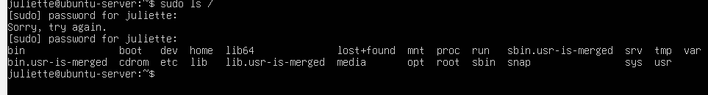

2. IP Address Problem
Problem
I ran the command:
ip addr
The system showed two IP addresses on the same interface:
- Correct: 192.168.56.102/24
- Incorrect: 192.168.100.10/24 (added by break script)
This duplicate IP caused network conflicts.
Screenshot: showing both IPs.
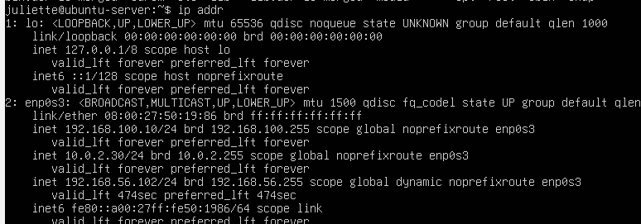

Solution
I removed the incorrect IP:
sudo ip addr del 192.168.100.10/24 dev enp0s3
Confirmation
I ran:
ip addr
Now only the correct IP remained.
Screenshot: “after fix” showing only 192.168.56.102.
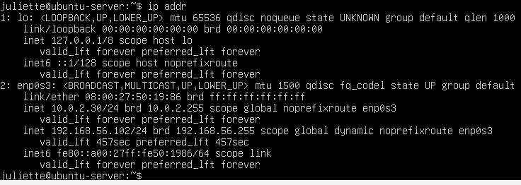
3. Missing Default Gateway
Problem
I checked:
ip route
The routing table was missing a default route.
Without a gateway, the VM cannot reach the internet or DNS.
Screenshot: showing no “default via”.
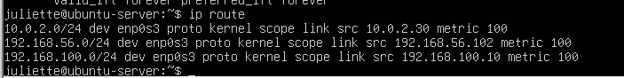

Solution
Since my Ubuntu Virtual Machine a uses NAT adapter, the correct gateway is always:
10.0.2.2
So, I added the default route manually:
sudo ip route add default via 10.0.2.2
Confirmation
I checked again:
ip route
Now it showed:
default via 10.0.2.2 dev enp0s3
Screenshot: of corrected routing table.
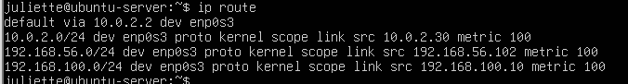

4. DNS Resolution Failure
Problem
When I tested DNS:
ping -c 2 google.com
I got:
Temporary failure in name resolution
This told me:
- The VM can reach the internet (because ping 8.8.8.8 works)
- DNS cannot translate domain names
- /etc/resolv.conf was broken by the script
Screenshot: of ping failure.
Solution — Fully Rebuild DNS Resolver
I fixed DNS by recreating the systemd resolver configuration.
Step 1 — Remove corrupted resolv.conf
sudo rm /etc/resolv.conf
Step 2 — Recreate correct symlink
sudo ln -s /run/systemd/resolve/stub-resolv.conf /etc/resolv.conf
Step 3 — Restart DNS service
sudo systemctl restart systemd-resolved
Step 4 — Verify service is running
systemctl status systemd-resolved
Service is active (running)
Screenshot: of systemd-resolved status.
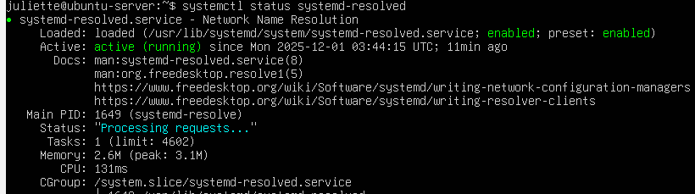

Step 5 — Test name resolution
ping -c 2 google.com
Result:
Google responded successfully → DNS fixed.
Screenshot: of successful ping.
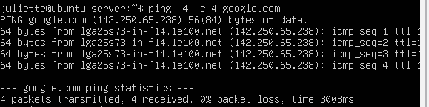

CENTOS TROUBLESHOOTING
Introduction
For my CentOS server, I first converted the professor’s script from a text file into a .sh file so it could run successfully. After running the script, I documented each problem and the steps used to solve it.

1. Running the Break Script (Script Conversion)
Problem
The professor’s break script was saved as a text file and could not run directly on CentOS.
Solution
I renamed and converted the file into a .sh script and made it executable:
mv break_system.txt break_system.sh
chmod +x break_system.sh
./break_system.sh
screenshot – script conversion / successful execution
2. IP Address Check (ip addr)
Problem
When I checked the IP address using ip addr, the system showed an extra interface/IP (192.168.100.x) even though only the NAT adapter was enabled.
This incorrect extra IP was added by the break script, and it does not belong to my active network.
screenshot — ip addr before fix
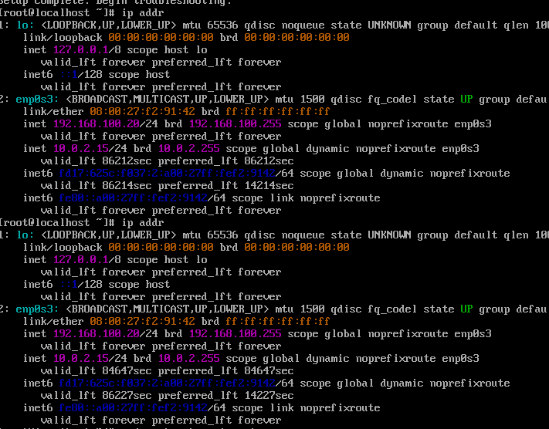
Solution
I removed the invalid IP address:
sudo ip addr del 192.168.100.20/24 dev enp0s3
After deletion, only the correct NAT IP remained (10.0.2.15).
Then I confirmed the fix:
ip addr show
Now only the correct NAT IP (10.0.2.15) appears
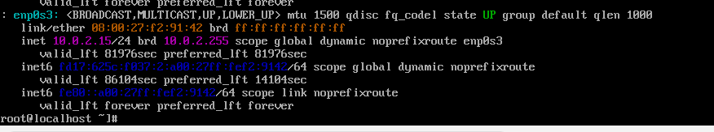
3. Problem Wrong IP/Gateway Showing in ip addr show and ip route
A. Evidence from ip addr show
Problem:
The IP address looked correct, but the routing table was wrong.
My CentOS is using NAT, so the correct gateway should always be 10.0.2.2.
But CentOS showed:
default via 192.168.100.1 dev enp0s3
This is a wrong gateway for NAT and causes all networking to fail.
Screenshot: of wrong default gateway: 192.168.100.1)
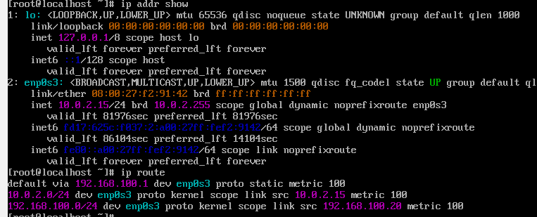
B. Solution – Fix the Gateway
I updated the gateway using nmcli:
nmcli connection modify enp0s3 ipv4.gateway 10.0.2.2
nmcli connection modify enp0s3 ipv4.method auto
systemctl restart NetworkManager

C. Verification — Correct Route
After restarting NetworkManager, ip route showed:
default via 10.0.2.2 dev enp0s3
Screenshot: showing default via 10.0.2.2)
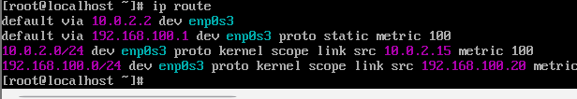

4. DNS Check (cat /etc/resolv.conf)
DNS Troubleshooting
Problem:
When I used the ping -c 2 google.com command;
I got a no name or service not known message
Screenshot: of failed ping BEFORE gateway fix
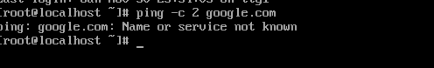

DNS Configuration Was Actually Fine, evidence from the resolv.conf file
/etc/resolv.conf showed valid DNS servers:
nameserver 8.8.8.8
nameserver 75.75.75.75
nameserver 1.1.1.1
Screenshot:
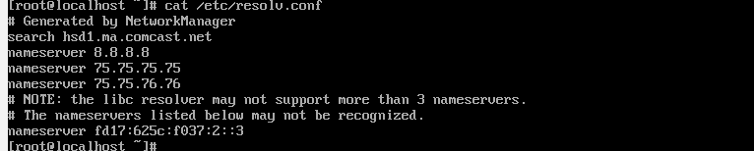
This proves the DNS entries were correct — google.com could nor be reached with a wrong default gateway.

Solution — Fixing the Gateway Automatically Fixed DNS
No DNS changes were required.
Once the default gateway was corrected to 10.0.2.2, DNS worked immediately.

Verification — Successful Ping
ping -c 2 google.com
Output:
2 packets transmitted, 2 received, 0% packet loss
Screenshot:
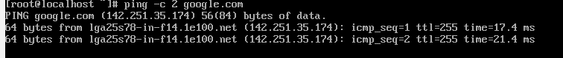

QUESTION 2 — SCRIPT DOCUMENTATION (UBUNTU SERVER)

Purpose of the Script
This Bash script automatically checks the basic network settings on my Ubuntu server:
- IP address
- Default gateway
- DNS settings
- Internet connectivity
It also saves all results into a text report for troubleshooting.

System Requirements
No updates or additional packages were needed.
Ubuntu already includes all commands used in the script:
- ip
- route / ip route
- cat
- ping
- tee

Script Location
/home/juliette/network_troubleshoot.sh
Report Output Location
/home/juliette/network_troubleshoot_report.txt

How to Run the Script
- Make the script executable:
chmod +x network_troubleshoot.sh
- Run the script:
Sudo ./network_troubleshoot.sh

Screenshot: Script Running (sudo ./network_troubleshoot.sh)

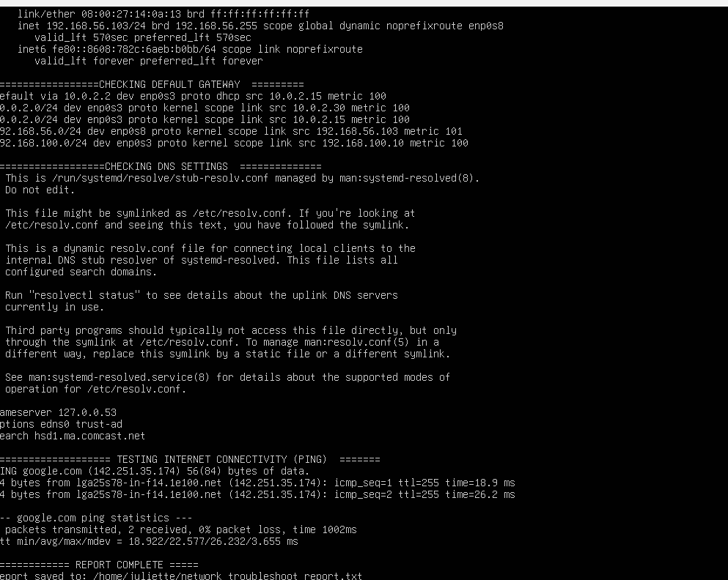

Screenshot: Report file (cat /home/juliette/network_troubleshoot_report.txt)
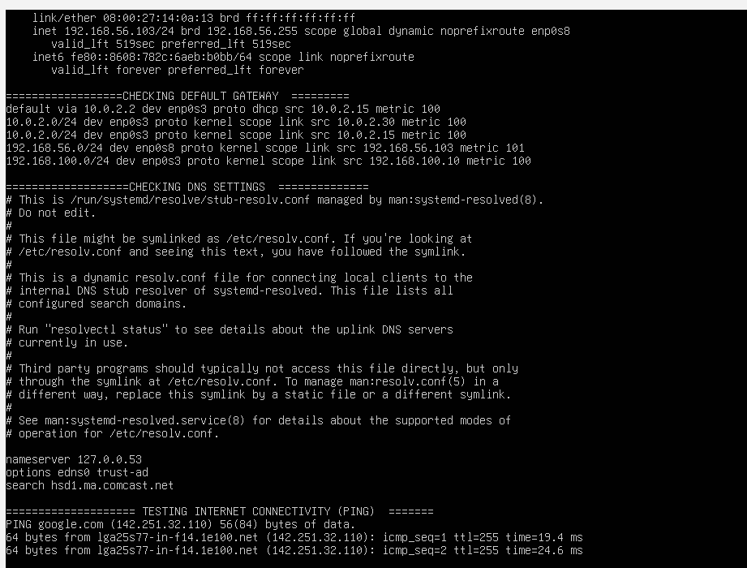

NETWORK TROUBLESHOOTING SCRIPT DOCUMENTATION — CENTOS SERVER
Purpose of the Script
This script automatically checks the three networking settings that caused issues on my CentOS server:
- IP address (to confirm the interface has a valid IP)
- Default gateway (to verify CentOS is using the correct NAT gateway)
- DNS settings (to confirm nameservers are working)
- Internet connectivity (using ping)
The script also creates a text report that saves all results.

System Requirements
- No system updates were required.
- All commands used (ip, route, cat, ping, tee) already exist by default on CentOS.

Script Location
/root/network_troubleshoot.sh
Report Output Location
/root/network_troubleshoot_report.txt

How to Run the Script
- Make the script executable:
chmod +x network_troubleshoot.sh
- Run the script:
./network_troubleshoot.sh
- After running, view the report:
cat /root/network_troubleshoot_report.txt

Required Screenshot: Script Running
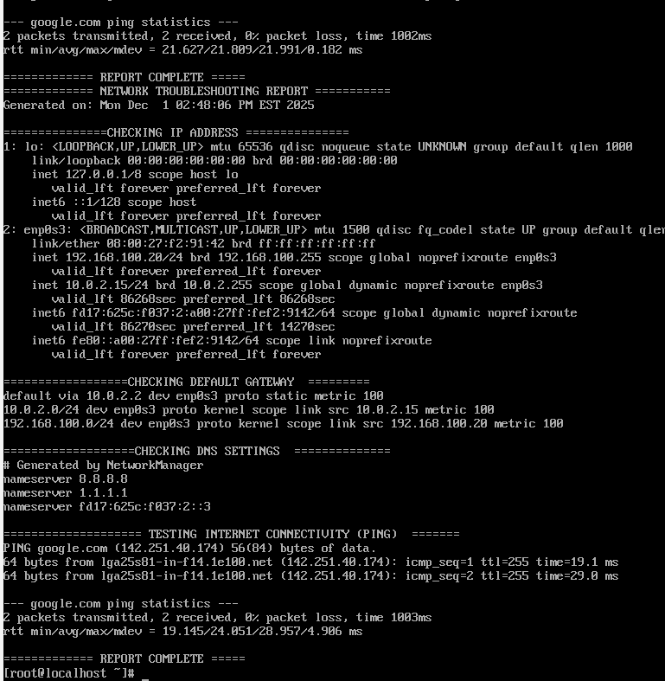
Screenshot: Report File

QUESTION 3 — Cron Job Documentation
Purpose of the Cron Job
A cron job lets the server automatically run my troubleshooting script at a scheduled time without me manually typing the command. This is useful because network problems can happen randomly, and having the script run automatically helps detect issues early.

Why I Chose the Frequency
I chose to run the script once every day because the networking on my servers (Ubuntu and CentOS) does not change often. Running it daily is enough to capture problems such as a bad gateway, DNS failures, or an IP address changing.

How I Set Up the Cron Job
I used the crontab -e command to open the cron table.
Inside the file, I added one line that tells cron when to run the script and which script to run.
Steps I used:
- Open cron editor:
crontab -e
- Add this line (example: runs every day at 9:00 AM):
0 9 * * * /root/network_troubleshoot.sh
- Save and exit the editor with the wq: command
Cron automatically installs the new schedule after saving:
crontab: installing new crontab

Sample Cron Job Entry
Example:
0 9 * * * /root/network_troubleshoot.sh
This means:
run the script every 9 minutes
script path: /root/network_troubleshoot.sh

Screenshot: Cron running on my server
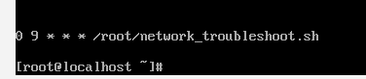

QUESTION 4 —
Document for the Boot System and Emergency Boot System

SECTION 1 — Accessing the GRUB Boot Menu
This section explains the boot system part.
Step 1: Power off the VM completely.
Then power it back on.
Step 2: BEFORE the login screen appears, hold the key:
Press ESC repeatedly
This opens the GRUB menu.
Insert Screenshot #1 — GRUB Menu
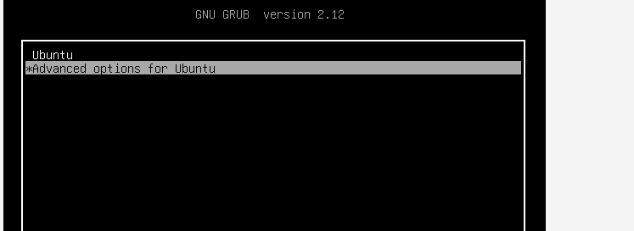

SECTION 2 — Open Advanced Options (Boot System)
Once the GRUB menu appears:
- Select Advanced options for Ubuntu
- Press Enter
Screenshot #2 — Advanced Options Menu

SECTION 3 — Enter Recovery Mode (Emergency Boot)
In the Advanced Options menu:
- Choose the entry that ends with:
(recovery mode)
- Press Enter
This loads the official Ubuntu Recovery Menu.
Screenshot #3 — Recovery Mode Menu
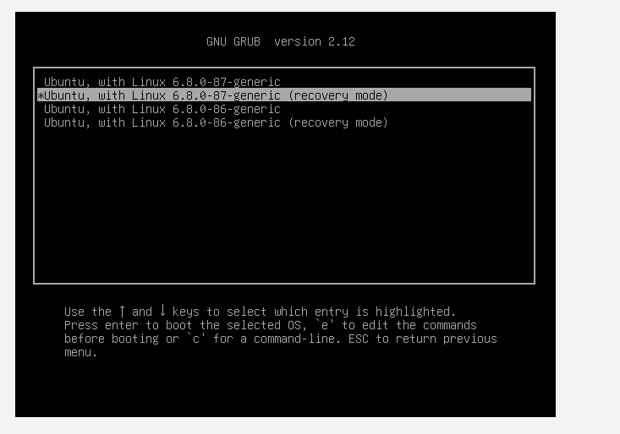
SECTION 4 — Enter Emergency Root Shell
On the Recovery Menu:
- Scroll down to:
root – Drop to root shell prompt
- Press Enter
You will then see a message asking to remount the filesystem.
Screenshot #4 — “Do you want to continue?” YES Screen
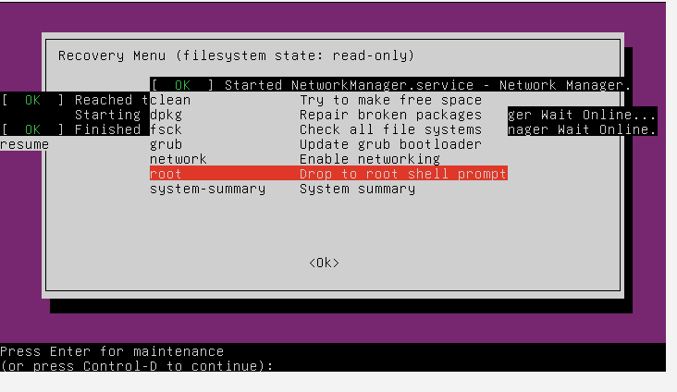

SECTION 5 — You Are Now in EMERGENCY MODE
Screenshot #5 — Root Shell Prompt
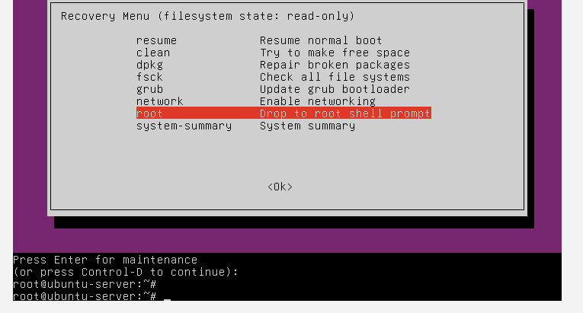
Screenshot: Successfully entered emergency root shell mode.
This allows system repair, file changes, fixing sudo, repairing network, etc.
SECTION 6 — Demonstrate Daemon Control
Question 4 also requires me to show how to control daemons (system services).
At the root shell or normal boot, run:
systemctl status
Screenshot #6 — systemctl status
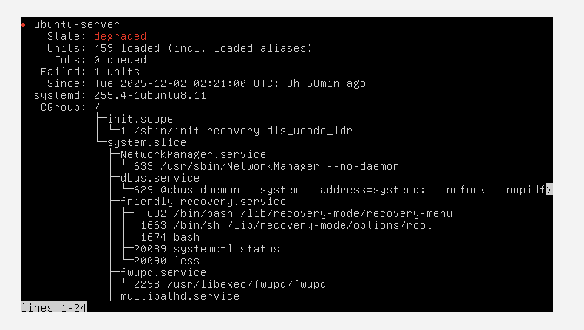

SECTION 7 — Short Summary
In this section, I demonstrated how to access the GRUB boot system by rebooting and pressing ESC to open the menu. From there, I selected “Advanced options”, entered Recovery Mode, and dropped into the root shell prompt to simulate an emergency repair environment. This mode allows a technician to fix broken packages, network issues, or system files even when normal boot fails. I also demonstrated basic daemon management using systemctl to view and manage system services.

Sources Used
- https://crontab.guru

- https://man7.org/linux/man-pages/man5/crontab.5.html
Link to My GitHub
Network_troubleshoot/network_troubleshoot.sh at main · julietteagwe-cloud/Network_troubleshoot

